For many passengers on the Greenwich Line, the changes will mean longer journeys, inconvenience, and higher cost. 6.4million passengers use the Greenwich Line each year, and the impact of these proposed changes on them must be reduced by allowing alternative journeys at no extra cost, and running shuttle buses where appropriate. The current level of service on the Greenwich Line must also be maintained.

The Greenwich Line Users’ Group will be responding to the timetable consultation and is **keen to get as much input as possible. The Users’ Group is inviting anybody interested to attend its next meeting, at which we will be agreeing on our response. This will be on:**

**Monday 3rd February 2014 , at 6.30pm**

**In the Tom Smith Community Centre**

**(next to Maze Hill station)**

**YOU ARE WELCOME TO ATTEND**

**Greenwich Line Users’ Group greenwichline@outlook.com**

Southeastern Railway are consulting Rail User Groups about their proposed changes to the rail timetable from January 2015.

These changes remove from the Greenwich Line all direct trains to Charing Cross,

Rebuilding work at London Bridge also means that it will not be possible for at least three years to change at London Bridge on to a Charing Cross service.

**FROM JANUARY 2015**

**NO MORE TRAINS TO WATERLOO EAST AND CHARING CROSS**

*

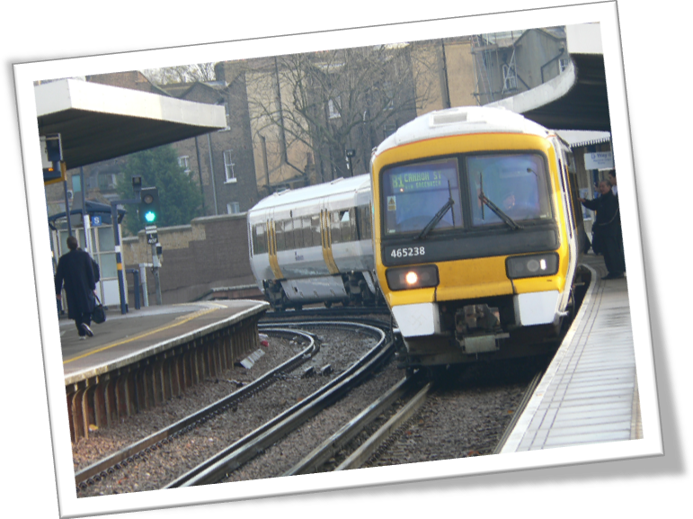

All Change on Greenwich Lines to London